For Immediate Release

Introducing Mateus Art Saving Dreams & I’m Fine Collections

Miami-based Mayra Mateus, Emerging Pop Artist Superstar,
Has been Commissioned by Brands including Puma, Hugo Boss & Foot Locker

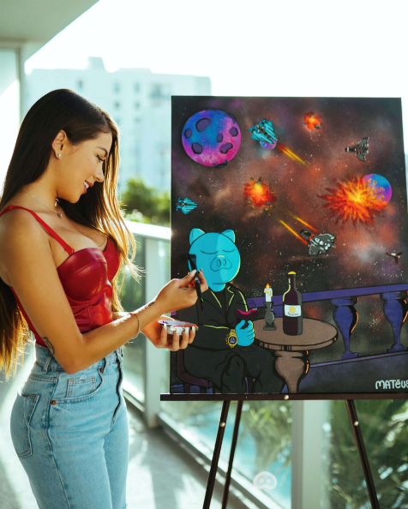

Miami, FL October 07, 2021 Born in 1995 in Cali, Colombia, Mayra Mateus, known professionally as Mateus Art (www.mateusart.com), is an emerging pop artist superstar with a powerful message. After a difficult transition from Colombia to Miami, she and her mother lived in a one-room apartment. When she was 16, Mayra became what she calls a “professional cashier” as she held down jobs three jobs at a pizzeria, a department store and on Miami Beach. She started painting murals at that time and discovered her passion for art.
Inspired, she created a brand that she trademarked around a piggy bank character and has created a portfolio of various mediums and pieces incorporating this symbol. The message she portrays with pigs and piggy banks is “Saving Dreams,” to remind people that pursing your dreams is more important than focusing on money.
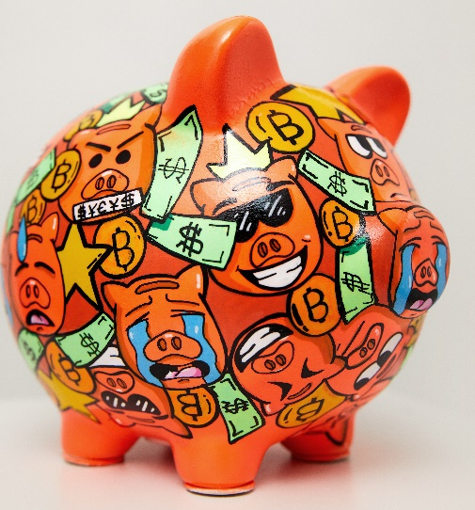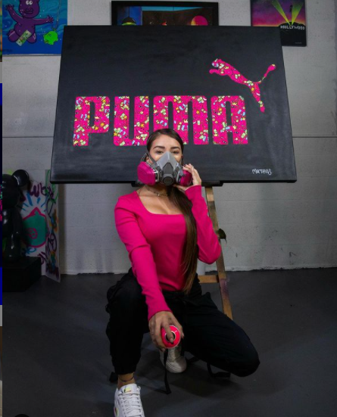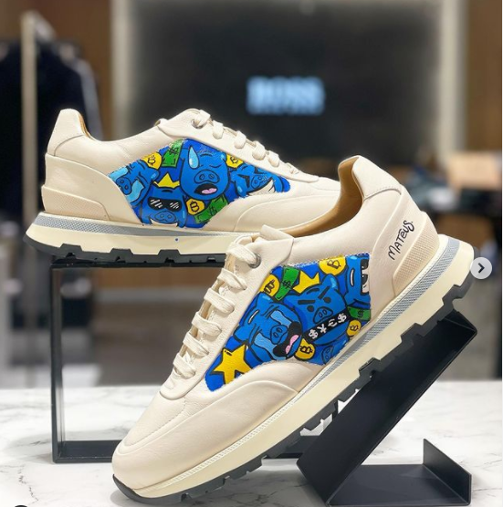
From Saving Dreams Collection Commissioned work for Puma Commissioned work for Hugo Boss/Foot Locker

Like many young artists, Mayra launched her brand on Instagram (mateusart_) where she very quickly gained devoted followers who loved her pop art piggy banks and piggy artworks, and was noticed by such brand names as Puma, Hugo Boss and Footlocker, who have since commissioned her for original artwork.
As she grew in her art and self-confidence, Mayra discovered the street and spray-paint style of vibrant Wynwood Village in Miami, a neighborhood well-known for its pop art murals covering the walls of many buildings in the district. The colors, shapes, stories and pop art spoke personally to Mayra, and she knew this style was her calling.
Another message Mayra conveys in her work is the “I’m Fine” Collection. “Many of us tend to say that we are just fine, when in reality we are not,” she says. Her “I’m Fine” collection is the representation of our sensitive side, a side we may hide from the world. Like many of us, Mayra has fought depression in her life, and her art has given her an outlet to express herself and hopefully inspire others to be true to themselves. She adds, “Depression is real. As a society, we must acknowledge it and stop ignoring that pain and depression affect so many at different points in their lives.”
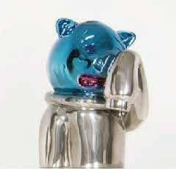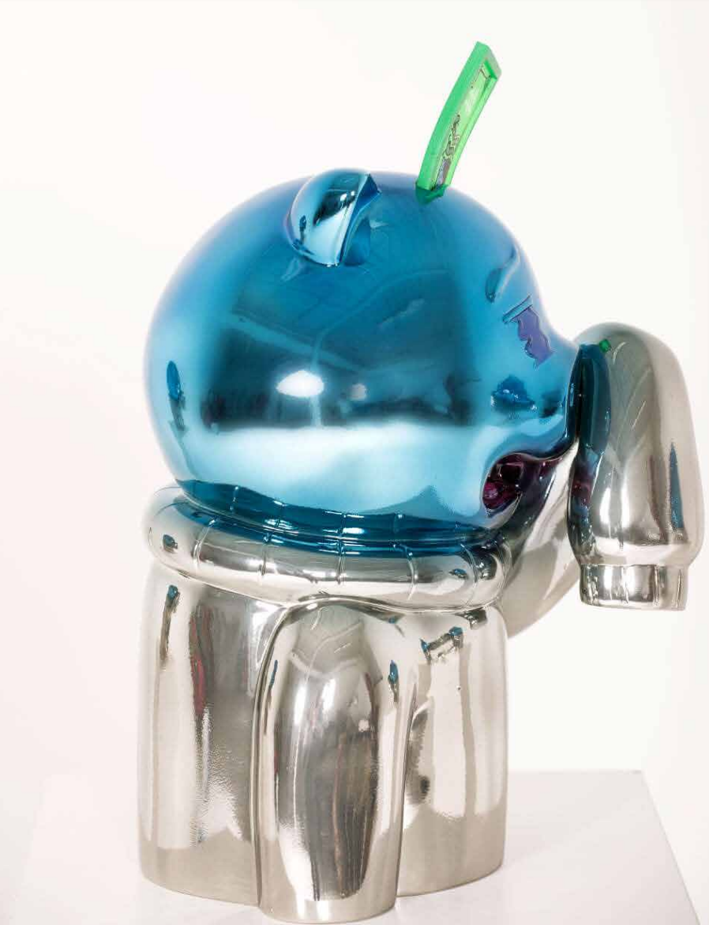
From I’m Fine Collection
Today, Mateus Art has an eclectic line of original artworks and products including:
- Dream Saver Piggy Banks
- Piggy Paintings, Sculptures and Murals
- “I’m Fine” Limited Collection
- Mugs, Pillows and Hoodies
- Customized Sneakers
- Live Painting Events
- And more
According to Mateus “When I paint, I usually start by spray painting the background on a blank canvas, then draw the pigs on top with pencil. After that, I add acrylic colors and finish with fine details, letting the magical process of creation and creativity to unfold. For my sculptures, I start with a digital design, then start sculpting and sanding. Once I have the perfect shape, I make a mold and finish by airbrushing the artwork.”
Mayra Mateus is bilingual in Spanish and English and available for press interviews and demonstrations.

Media Contact:
Kim Morgan
Kmorganpr1@gmail.com
954-261-2149

